Configuration of an Alarm System for a New Benchmark System
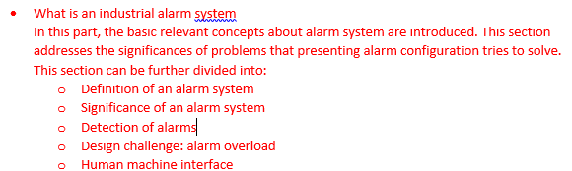
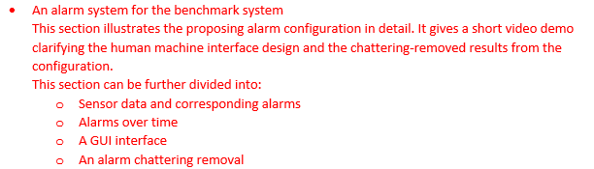
**Introduction
Alarm Detection Mechanism
Design Challenges
Overview of Benchmark system
Given the significance of alarm system and critical design challenges, it is helpful for researchers to have a simulation for alarm system so that they can test their innovative ideas quickly and effectively. Since an alarm system is a monitor for abnormal events in the plant, it is necessary to have an alarm generation mechanism to produce such abnormal events. This section introduces the benchmark system developed by Japan Society for the Promotion of Science (JSPS) that has been selected for alarm generation purpose.
The benchmark system that being monitored is a rigorous dynamic chemical plant simulation of a vinyl acetate monomer. It provides a variety of scenarios commonly encountered in practical chemical plant operation including some scenarios that are unavailable in other simulation tools. For example: simulation transient operations including start-up and shut-down process, generation of noises and disturbances based on measurement in real plant, simulation of 36 characteristic malfunctions and etc. [ ] Furthermore, this system also provides an excel interface that can communicate with external applications so that the simulation can be controlled by external advanced control logic.

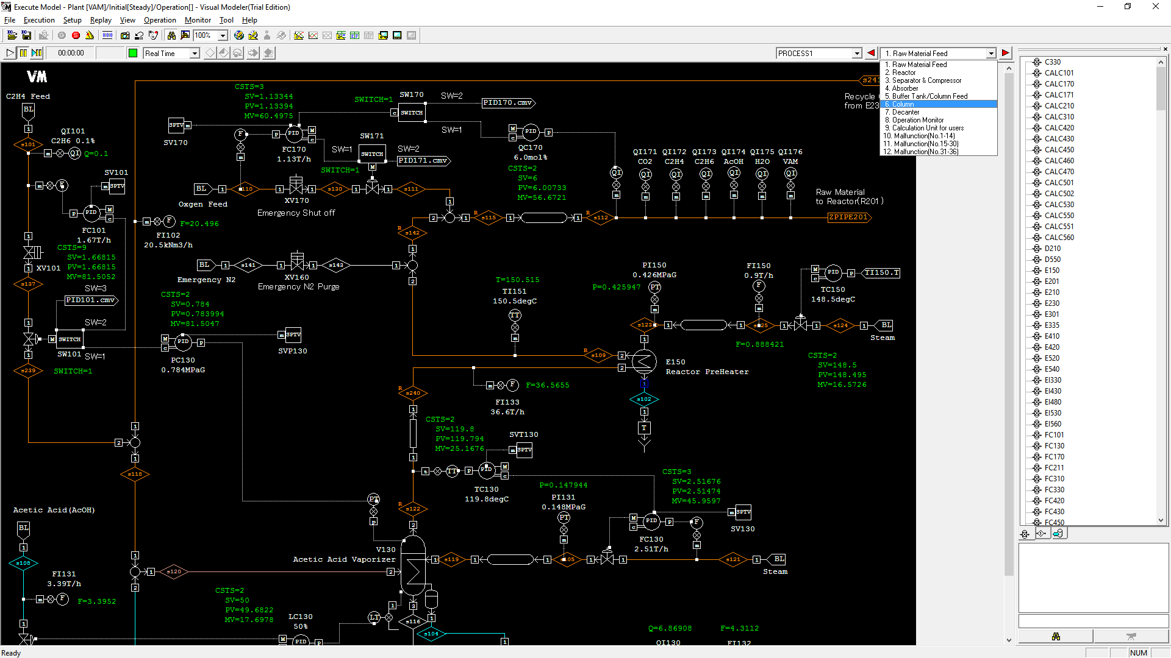
Sensors
Figure 1: An overview of JSPS VAM simulator
(introduction of sensor to alarm system) Although virtually all physical variables like liquid enthalpy are accessible in the benchmark system, only sensor data are accessible for external software. This limitation reflects the fact that sensor data are most common raw data input to an alarm system.(physical location of sensors) The available sensor types are:
- Flow rate indicator(FI)
- Pressure indicator (PI)
- Pressure difference indicator (PDI)
- Temperature indicator (TI)
- Level indicator (LI)
- Quality (composition) indicator (QI)
Collection of Sensor Data
The benchmark system provides two ways of collecting data. The one used for the configuration of alarm system is the off-line method. Off-line method requires the completion of simulation before alarm analysis and flushes all data into an excel file. Since the time tag is provided, the collected data can also be used to develop an online alarm system. The data format is provided as below:
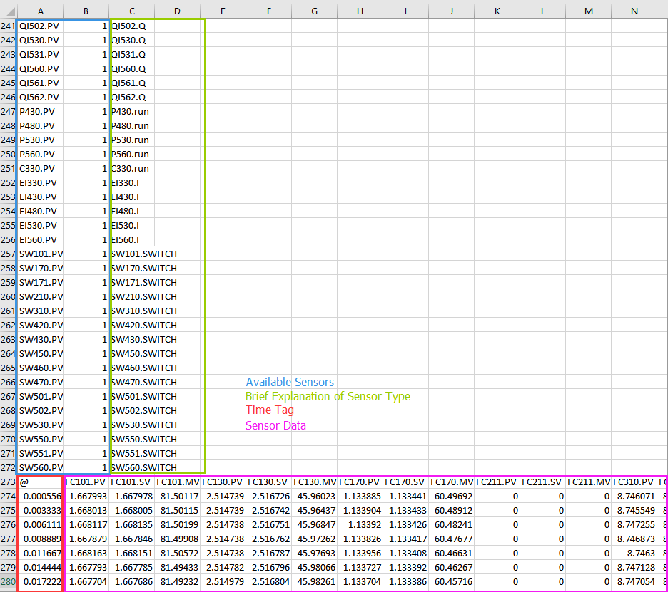
Figure 2: Data format
Off-line analysis method
Alarm Configuration
Alarm Detection
Operator Interface
Chattering Removal
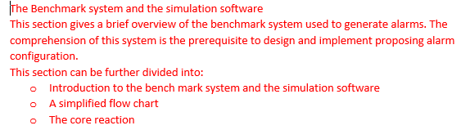
- Summary
- Possible future work

